IBDA (2024) – Week 3 exercises assignment (Name: Kunqi Zhang, B990364988)
Use this file to answer by directly editing. Once done save it and submit through the PandA assignment as attachment.
- The three molecules below contain the seven most common reactive groups in biology. Most molecules in the cell are built from these functional groups. Indicate (circle) and name the seven different types of functional groups in these three molecules.
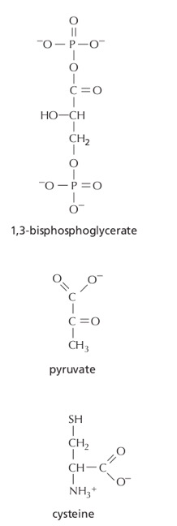
Amino
Carboxyl
Sulfhydryl
Carboxyl
Carbonyl
Methyl
Phosphate
Carbonyl
Hydroxyl
Phosphate
- Aspirin is a weak acid (see Figure below) that is taken up into the bloodstream by diffusion through cells lining the stomach and the small intestine. Aspirin crosses the plasma membrane of a cell most effectively in its uncharged form; in its charged form it cannot cross the hydrophobic lipid bilayer of the membrane. The pH of the stomach is about 1.5 and that of the lumen of the small intestine is about 6.0. Is the majority of the aspirin absorbed in the stomach or in the intestine? Explain your reasoning.

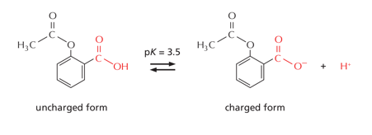

Answer: In the stomach, the pH of the stomach is about 1.5, it’s much lower than the pKa 3.5 of aspirin, so aspirin stays uncharged form when it is in the stomach, but in the intestine, the pH is about 6.0, the aspirin can diffuse across the hydrophobic lipid bilayer of the membrane easily. And aspirin is in charged form, it will be hard to absorbed.

